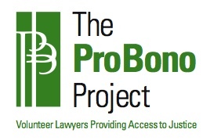
Name Change for a Minor Questionnaire
DATE: ______________
CHILD’S INFORMATION
NAME____________________________________ DATE OF BIRTH____________________
AGE__________ SOCIAL SECURITY NUMBER ____________________________________
ADDRESS ____________________________________________________________________
CITY, STATE, ZIP______________________________________________________________
MOTHER’S INFORMATION
NAME_________________________________________PHONE #______________________
ADDRESS____________________________________________________________________
CITY, STATE, ZIP______________________________________________________________
DATE OF BIRTH___________________________
FATHER’S INFORMATION
NAME_________________________________________PHONE #______________________
ADDRESS____________________________________________________________________
CITY, STATE, ZIP______________________________________________________________
DATE OF BIRTH___________________________
INFORMATION REGARDING NAME CHANGE
Are the biological parents married? YES / NO [circle one]
Are the biological parents in agreement regarding the child’s name change? YES / NO
IF YES, please provide a letter from each parent saying they approve of the child’s name change.
If they are not in agreement regarding the child’s name change, or unable to consent via letter, please explain: _________________________________________________________________ ________________________________________________________________________________________________________________________________________________________________________________________________________________________________________________________________________________________________________________________

